Instructions for Adjusting the Day Care Events Calendar

Log into the website at <http://outreach.cs.dal.ca/daycare/wp-login.php>

**Events Calendar:**

The Event Calendar feature displays events in a calendar format which allows for easy sharing of events. This feature can also be displayed on the (sidebar) right hand side of the page, in text format that can direct the visitor to the calendar format.

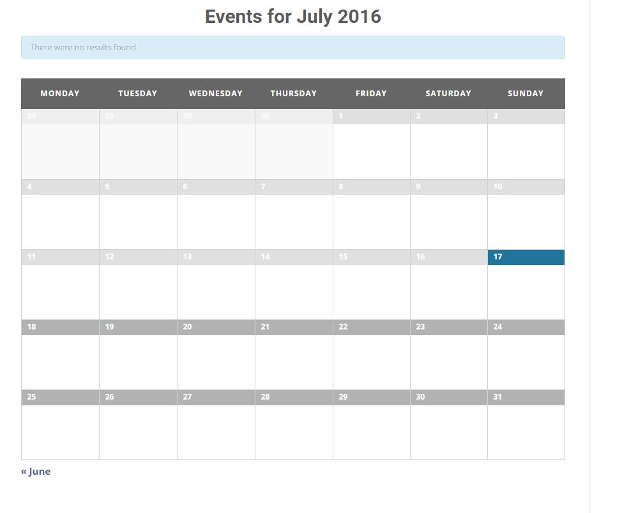

**Administration:**

Follow the steps below to make changes to the Events Calendar feature:

**Adding an event:**

1- On the main administration panel on WordPress, click on “Events” found in the left side Menu bar.

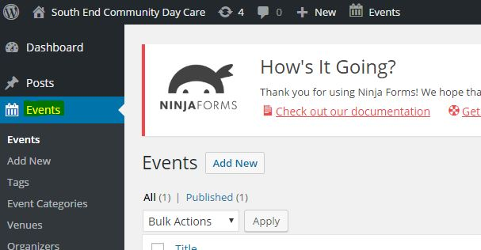

2- On the Events administration page select the “Add New” Button located near the “Events” title.

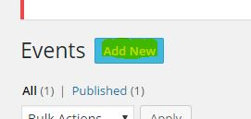

3- In this Panel input all the text field area’s that you would like to include for the event including and not limited to title, and event detail. The title area has the following text “Enter title here”. The event detail section is the large text field area directly below the title section.

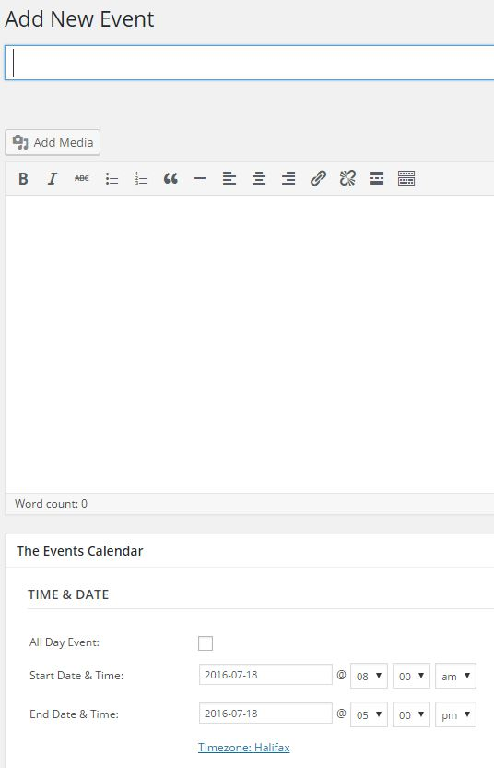

4- For adding media files, such as a picture, video, music (mp3). Select the “Add Media” Button found below the title text field. Once there click the button “Select Files” in the center of the page, and select a local media file. Once complete select “Insert into Post” button at the right bottom of the page. Doing this will place the media file in the event description.

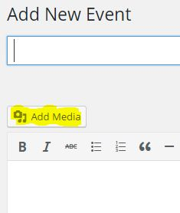

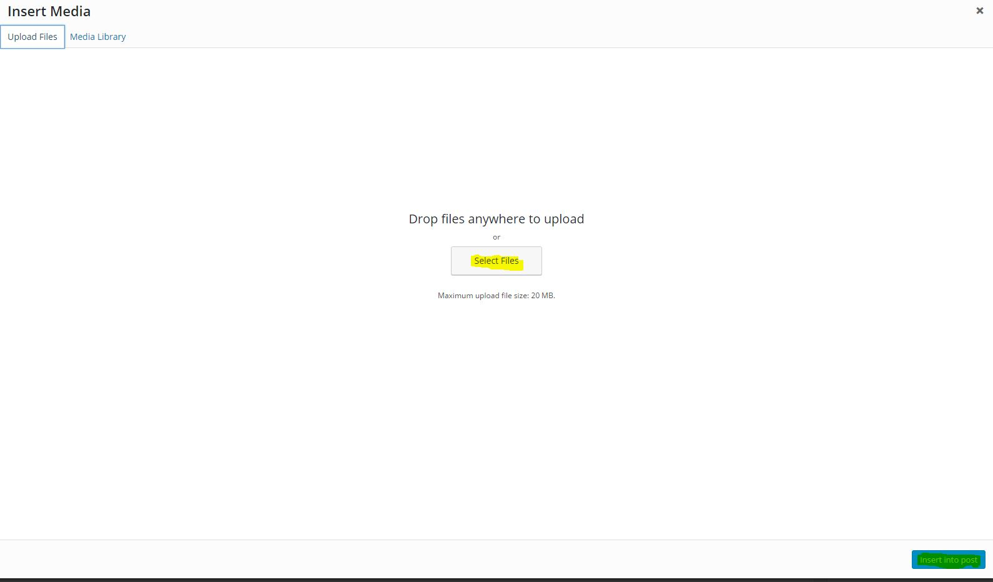

5- To add more details about the event such as time, date, location, and event organizer, scroll down the page and various sections are bolded with the specific headings.

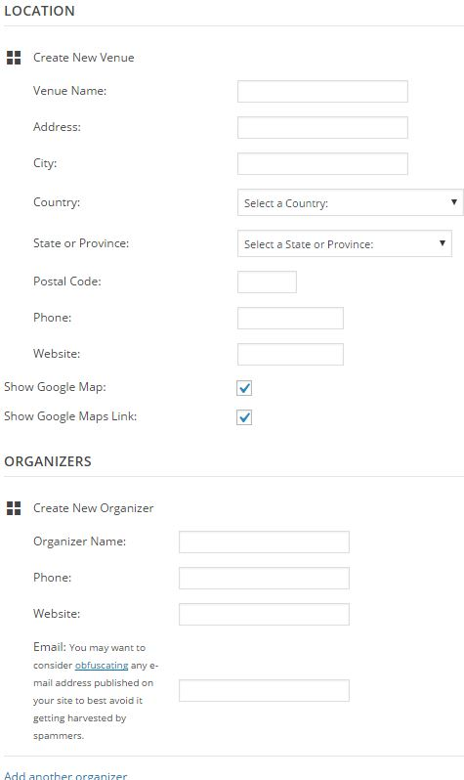

6- Once you are complete with personalizing the event, select the “Publish” button at the right top side of the page. Once complete a message on top of the page should say the following “Event published”.

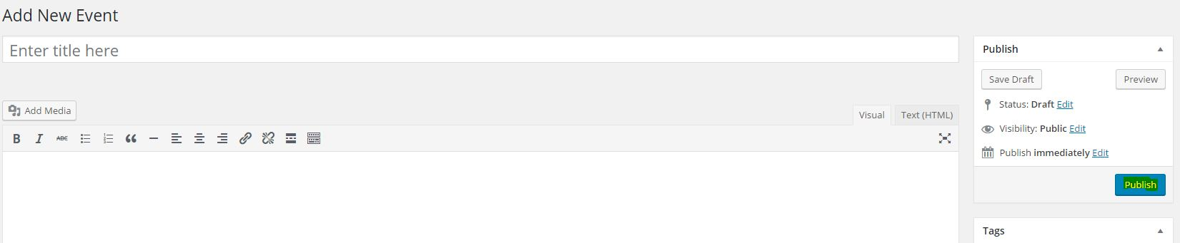

**Manage events:**

1- To manage events already made, go to the “Events” main menu which will direct you to a table format of all the events currently in place.

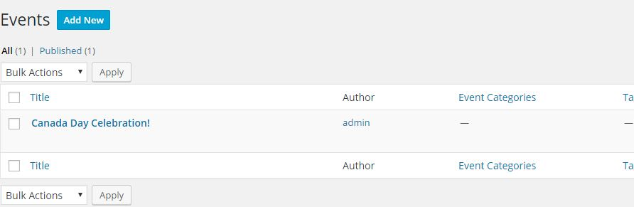

2- To delete one of the events in the table, hover the mouse on the event name, or if on a smartphone select the event name and various text will appear. Select “Delete” to delete the event.

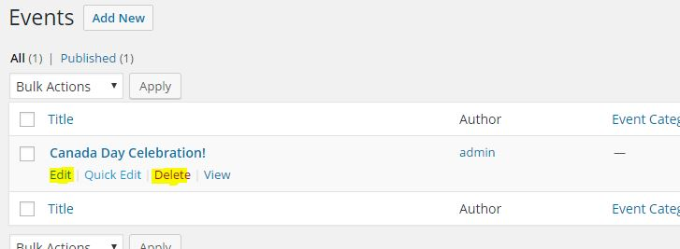

3- To update and make changes to an event, follow the same steps as directed in #2 above. However, select “Edit” instead. Once directed to the event panel, update the fields and select complete to save the changes made.